From : Head, Department of Basic Veterinary Sciences

To : Dean, Faculty of Veterinary Medicine and Animal Science

Re : Revised Calendar of Dates - Batch 2019/ 2020

Semester | Duration | Academic activity
1 | 13.12.2021 – 24.12.2021 (Two weeks) | Online teaching (Part time)
 | 24.12.2021 – 02.01.2022 (One week) | Vacation
 | 03.01.2022 – 04.03.2022 (Nine weeks) | Online teaching (Part time)
 | 05.03.2022 – 10.03.2022 (One week) | Vacation
 | 11.03.2022 – 08.04.2022 (Four weeks) | On campus academic program
 | 09.04.2022 – 24.04.2022 (Two weeks) | Vacation
 | 25.04.2022 – 09.05.2022 (Two weeks) | On campus academic program
 | 10.05.2022 – 16.05.2022 (One week) | Curfew & FUTA trade union action
 | 17.05.2022 – 08.07.2022 (Eight weeks) | On campus academic program
 | 09.07.2022 – 31.07.2022 (Three weeks) | Revision/Study leave
 | 01.08.2022 – 18.08.2022 (Three weeks) | End Semester Examination – Semester One
 | 19.08.2022 – 03.09.2022 (Two weeks) | Vacation
2 | 04.09.2022 – 21.10.2022 (Seven weeks) | On campus academic program
 | 22.10.2022 – 29.10.2022 (One week) | In-Course Assessments
 | 30.10.2022 – 23.12.2022 (Eight weeks) | On campus academic program
 | 24.12.2022 – 14.01.2023 (Three weeks) | Revision/Study leave
 | 15.01.2023 – 03.02.2023 (Three weeks) | End Semester Examination – Semester Two
Vacation and Repeat Exams  (Tentative) | 04.02.2023 – 25.02.2023 (Three weeks) | Vacation/Study leave
 | 26.02.2023 – 10.03.2023 (Two weeks) | End Semester Examination - Semester One (Repeat)
 | 11.03.2023 – 02.04.2023 (Three weeks) | Vacation/Study leave
 | 03.04.2023 – 21.04.2023 (Three weeks) | End Semester Examination - Semester Two (Repeat)

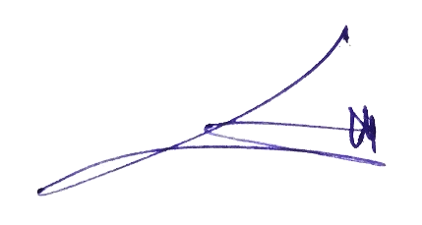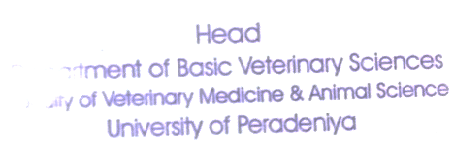

Dr. L.G.S. Lokugalappatti
Head, Department of Basic Veterinary Sciences

